ASSIGNMENT NO.5: Aggregate Functions and Data Analysis
Objective:
The objective of this practical is to help students understand how to analyze data using aggregate functions in MySQL. Students will learn how to use COUNT, SUM, AVG, MIN, and MAX, group records using GROUP BY, filter grouped records using HAVING, and analyze trends from datasets.

Introduction to Aggregate Functions
Aggregate functions are used to perform calculations on a group of records and return a single result. These functions are very useful for data analysis and report generation.
For example, in a college database, aggregate functions can be used to find the total number of students, average marks, highest marks, lowest marks, and total fees collected.

Common Aggregate Functions in MySQL
Function | Purpose | Example
COUNT() | Counts number of records | Count total students
SUM() | Calculates total value | Total fees collected
AVG() | Calculates average value | Average marks
MIN() | Finds minimum value | Lowest marks
MAX() | Finds maximum value | Highest marks

Example Use Cases
Requirement | Aggregate Function
Find total students | COUNT()
Find total marks | SUM()
Find average marks | AVG()
Find lowest marks | MIN()
Find highest marks | MAX()
Creating Sample Table and Inserting Records
For this assignment, we will use a table named StudentResult.

StudentResult Table Structure
Column Name | Data Type | Constraint
StudentID | INT | PRIMARY KEY
StudentName | VARCHAR(50)
Course | VARCHAR(30)
City | VARCHAR(30)
Marks | INT
FeesPaid | DECIMAL(10,2)

MySQL Code to Create Database and Table
CREATE DATABASE CollegeDB;
USE CollegeDB;
CREATE TABLE StudentResult ( StudentID INT PRIMARY KEY, StudentName VARCHAR(50), Course VARCHAR(30), City VARCHAR(30), Marks INT, FeesPaid DECIMAL(10,2));

MySQL Code to Insert Records

INSERT INTO StudentResult
(StudentID, StudentName, Course, City, Marks, FeesPaid)
VALUES
(1, 'Rahul Sharma', 'BSc IT', 'Mumbai', 78, 45000.00),
(2, 'Priya Patil', 'BCA', 'Pune', 85, 40000.00),
(3, 'Aman Verma', 'BSc CS', 'Nashik', 67, 42000.00),
(4, 'Sneha Joshi', 'BSc IT', 'Mumbai', 91, 45000.00),
(5, 'Karan Mehta', 'BCA', 'Thane', 74, 40000.00),
(6, 'Neha Shah', 'BSc IT', 'Pune', 88, 45000.00),
(7, 'Rohan Desai', 'BSc CS', 'Mumbai', 69, 42000.00),
(8, 'Meera Kulkarni', 'BCA', 'Nashik', 82, 40000.00),
(9, 'Arjun Nair', 'BSc IT', 'Thane', 59, 45000.00),
(10, 'Divya More', 'BCA', 'Mumbai', 93, 40000.00);

Sample Data
StudentID | StudentName | Course | City | Marks | FeesPaid
1 | Rahul Sharma | BSc IT | Mumbai | 78 | 45000.00
2 | Priya Patil | BCA | Pune | 85 | 40000.00
3 | Aman Verma | BSc CS | Nashik | 67 | 42000.00
4 | Sneha Joshi | BSc IT | Mumbai | 91 | 45000.00
5 | Karan Mehta | BCA | Thane | 74 | 40000.00
6 | Neha Shah | BSc IT | Pune | 88 | 45000.00
7 | Rohan Desai | BSc CS | Mumbai | 69 | 42000.00
8 | Meera Kulkarni | BCA | Nashik | 82 | 40000.00
9 | Arjun Nair | BSc IT | Thane | 59 | 45000.00
10 | Divya More | BCA | Mumbai | 93 | 40000.00

Using COUNT, SUM, AVG, MIN, and MAX
Aggregate functions help summarize numerical and record-based data.
Example 1: Count Total Students
SELECT COUNT(*) AS TotalStudents FROM StudentResult; Output
TotalStudents
10

Example 2: Find Total Fees Paid
SELECT SUM(FeesPaid) AS TotalFeesPaid FROM StudentResult; Output
TotalFeesPaid
424000.00

Example 3: Find Average Marks
SELECT AVG(Marks) AS AverageMarks FROM StudentResult;
Output
AverageMarks
78.6000

Example 4: Find Lowest and Highest Marks
SELECT MIN(Marks) AS LowestMarks, MAX(Marks) AS HighestMarks FROM StudentResult; Output
LowestMarks | HighestMarks
59 | 93

Explanation
Query Part | Meaning
COUNT(*) | Counts all records
SUM(FeesPaid) | Adds all fees paid
AVG(Marks) | Calculates average marks
MIN(Marks) | Finds lowest marks
MAX(Marks) | Finds highest marks
AS | Gives a temporary column name in output

Grouping Data using GROUP BY
The GROUP BY clause is used to group records that have the same value in one or more columns. It is commonly used with aggregate functions.
For example, we can group students by course and find how many students are enrolled in each course.
Syntax
SELECT column_name, aggregate_function(column_name) FROM table_name GROUP BY column_name;

Example 1: Count Students Course-Wise
SELECT Course, COUNT(*) AS TotalStudents FROM StudentResult GROUP BY Course; Output
Course | TotalStudents
BSc IT | 4
BCA | 4
BSc CS | 2

Example 2: Find Average Marks Course-Wise
SELECT Course, AVG(Marks) AS AverageMarks FROM StudentResult GROUP BY Course; Output
Course | AverageMarks
BSc IT | 79.0000
BCA | 83.5000
BSc CS | 68.0000

Example 3: Find Total Fees Course-Wise
SELECT Course, SUM(FeesPaid) AS TotalFees FROM StudentResult GROUP BY Course; Output
Course | TotalFees
BSc IT | 180000.00
BCA | 160000.00
BSc CS | 84000.00

Explanation
SQL Part | Purpose
GROUP BY Course | Groups records course-wise
COUNT(*) | Counts students in each course
AVG(Marks) | Calculates average marks of each course
SUM(FeesPaid) | Calculates total fees paid course-wise

Filtering Grouped Data using HAVING
The HAVING clause is used to filter grouped records. It is similar to WHERE, but WHERE filters individual rows before grouping, while HAVING filters groups after grouping.
Difference Between WHERE and HAVING
Clause | Used For | Used With Aggregate Function
WHERE | Filters individual rows | No
HAVING | Filters grouped data | Yes

Example 1: Display Courses Having More Than 2 Students
SELECT Course, COUNT(*) AS TotalStudents FROM StudentResult GROUP BY Course HAVING COUNT(*) > 2; Output
Course | TotalStudents
BSc IT | 4
BCA | 4

Example 2: Display Courses Having Average Marks Greater Than 80
SELECT Course, AVG(Marks) AS AverageMarks FROM StudentResult GROUP BY
Course HAVING AVG(Marks) > 80; Output
Course | AverageMarks
BCA | 83.5000

Example 3: Display Cities Having Total Fees Greater Than 80000
SELECT City, SUM(FeesPaid) AS TotalFees FROM StudentResult GROUP BY City HAVING SUM(FeesPaid) > 80000;
Output
City | TotalFees
Mumbai | 172000.00
Pune | 85000.00
Nashik | 82000.00

Analyzing Trends in Datasets
Aggregate functions, GROUP BY, and HAVING are very useful for finding trends in datasets.
Trends help users understand patterns, performance, and business insights.
Trend Analysis Examples
Analysis Requirement | MySQL Query Purpose
Which course has the highest number of students? | Count students course-wise
Which city has more students? | Group students city-wise
Which course has the highest average marks? | Average marks course-wise
Which course collected the highest fees? | Sum fees course-wise
Which course has weak performance? | Find courses with low average marks
Which cities generated more fees? | Group by city and sum fees

Example 1: Analyze Student Count City-Wise
SELECT City, COUNT(*) AS TotalStudents FROM StudentResult GROUP BY City ORDER BY TotalStudents DESC;
Output
City | TotalStudents
Mumbai | 4
Pune | 2
Nashik | 2
Thane | 2

Example 2: Analyze Course Performance
SELECT Course, COUNT(*) AS TotalStudents, AVG(Marks) AS AverageMarks, MIN(Marks) AS LowestMarks, MAX(Marks) AS HighestMarks FROM StudentResult GROUP BY Course;
Output
Course | TotalStudents | AverageMarks | LowestMarks | HighestMarks
BSc IT | 4 | 79.0000 | 59 | 91
BCA | 4 | 83.5000 | 74 | 93
BSc CS | 2 | 68.0000 | 67 | 69

Example 3: Display High-Performing Courses
SELECT Course, AVG(Marks) AS AverageMarks FROM StudentResult GROUP BY
Course HAVING AVG(Marks) >= 80 ORDER BY AverageMarks DESC; Output
Course | AverageMarks
BCA | 83.5000
Summary Table
Concept | Purpose | Example
COUNT() | Counts records | Total students
SUM() | Adds numeric values | Total fees
AVG() | Calculates average | Average marks
MIN() | Finds lowest value | Lowest marks
MAX() | Finds highest value | Highest marks
GROUP BY | Groups similar records | Course-wise report
HAVING | Filters grouped results | Courses with average marks above 80
ORDER BY | Sorts analysis output | Highest to lowest total students

Questions:
Q1) Create a MySQL database named CollegeDB and a table named StudentResult.
The table should contain the following columns:
Column Name | Data Type | Constraint
StudentID | INT | PRIMARY KEY
StudentName | VARCHAR(50)
Course | VARCHAR(30)
City | VARCHAR(30)
Marks | INT
FeesPaid | DECIMAL(10,2)
Insert at least 10 records into the table.

CREATE DATABASE CollegeDB;
USE CollegeDB;

CREATE TABLE StudentResult (
StudentID INT PRIMARY KEY,
StudentName VARCHAR(50),
Course VARCHAR(30),
City VARCHAR(30),
Marks INT,
FeesPaid DECIMAL(10,2)
);

INSERT INTO StudentResult (StudentID, StudentName, Course, City, Marks, FeesPaid) VALUES
(1, 'Rahul Sharma', 'BSc IT', 'Mumbai', 78, 45000.00),
(2, 'Priya Patil', 'BCA', 'Pune', 85, 40000.00),
(3, 'Aman Verma', 'BSc CS', 'Nashik', 67, 42000.00),
(4, 'Sneha Joshi', 'BSc IT', 'Mumbai', 91, 45000.00),
(5, 'Karan Mehta', 'BCA', 'Thane', 74, 40000.00),
(6, 'Neha Shah', 'BSc IT', 'Pune', 88, 45000.00),
(7, 'Rohan Desai', 'BSc CS', 'Mumbai', 69, 42000.00),
(8, 'Meera Kulkarni', 'BCA', 'Nashik', 82, 40000.00),
(9, 'Arjun Nair', 'BSc IT', 'Thane', 59, 45000.00),
(10, 'Divya More', 'BCA', 'Mumbai', 93, 40000.00);
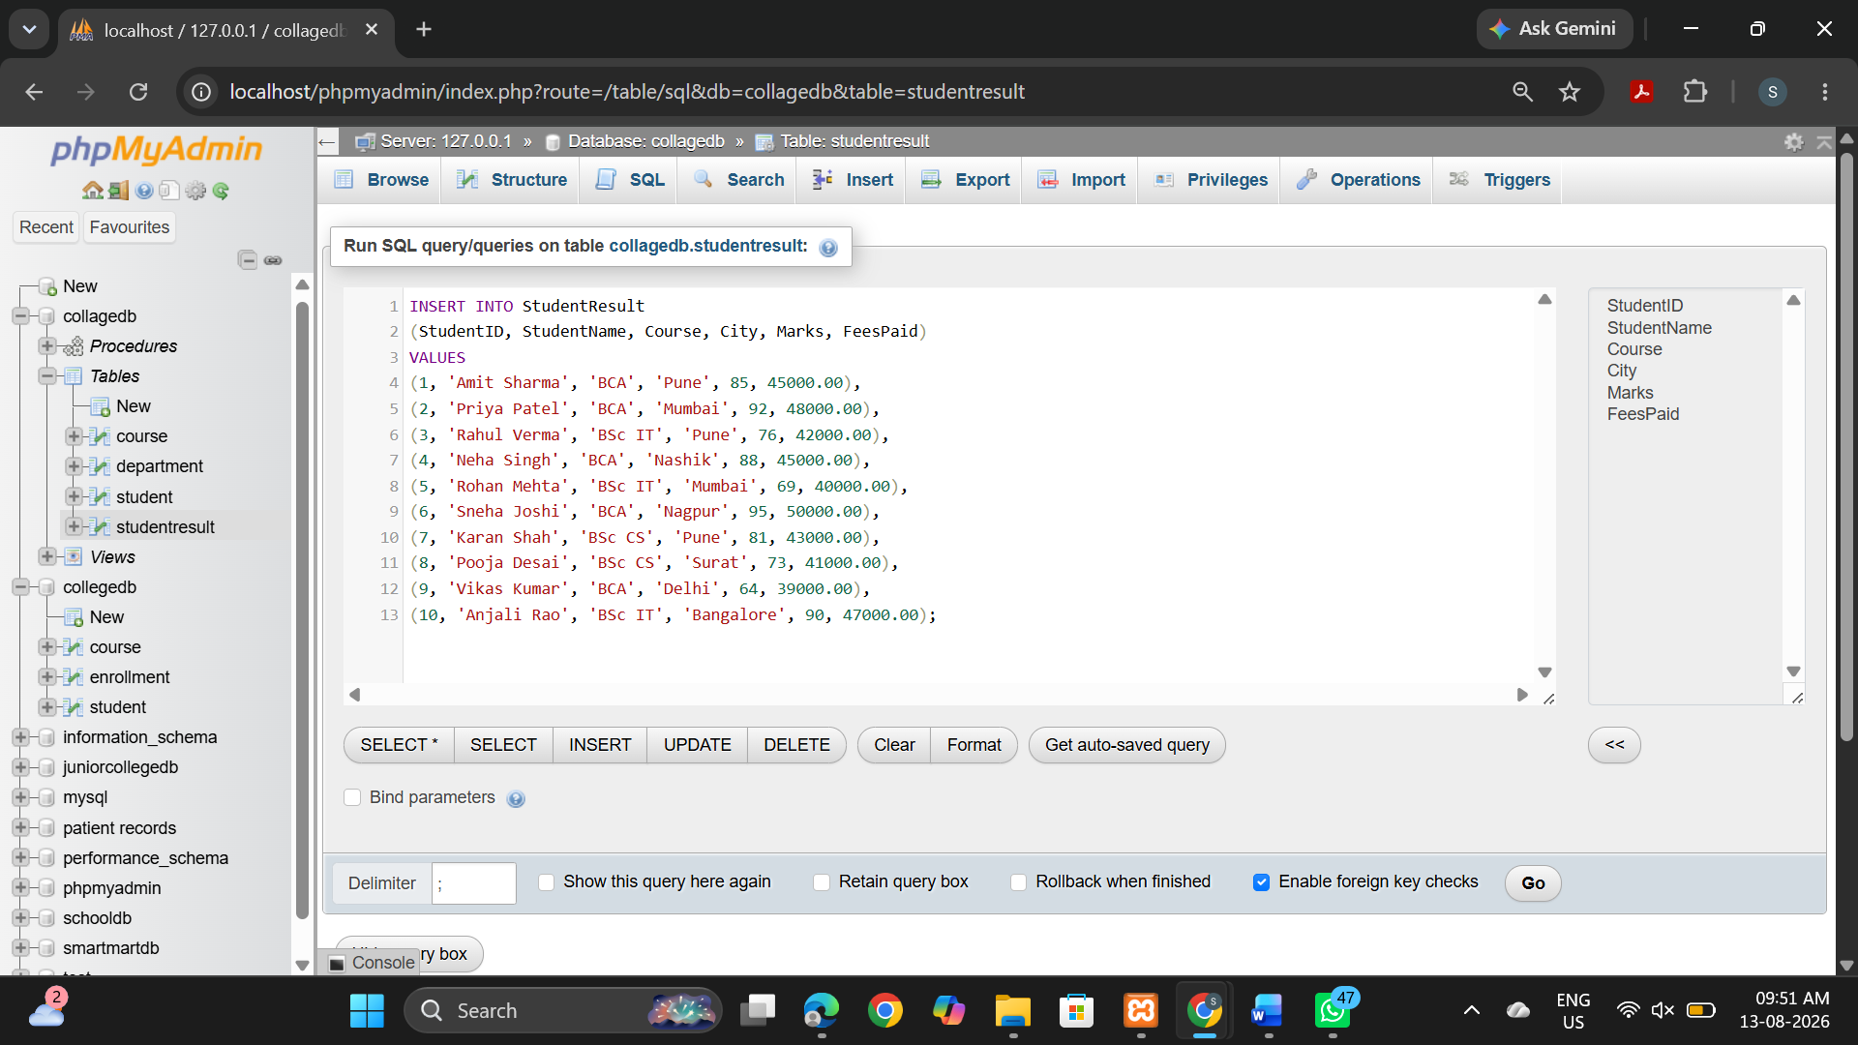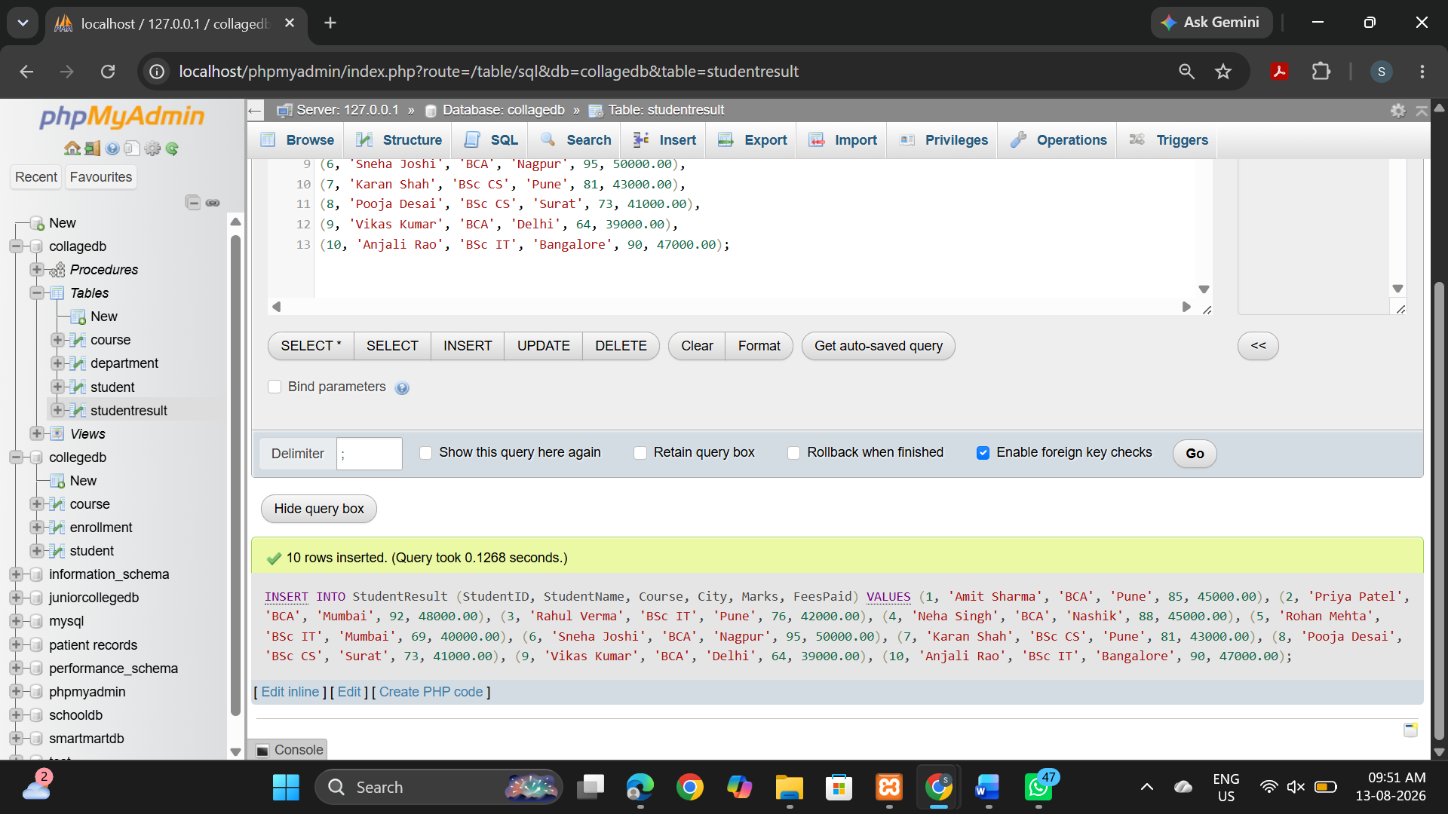
Q2) Write MySQL queries to find the following from the StudentResult table:
Requirement
Total number of students
Total fees paid
Average marks
Lowest marks
Highest marks

SELECT COUNT(*) AS TotalStudents FROM StudentResult;

SELECT SUM(FeesPaid) AS TotalFeesPaid FROM StudentResult;

SELECT AVG(Marks) AS AverageMarks FROM StudentResult;

SELECT MIN(Marks) AS LowestMarks FROM StudentResult;

SELECT MAX(Marks) AS HighestMarks FROM StudentResult;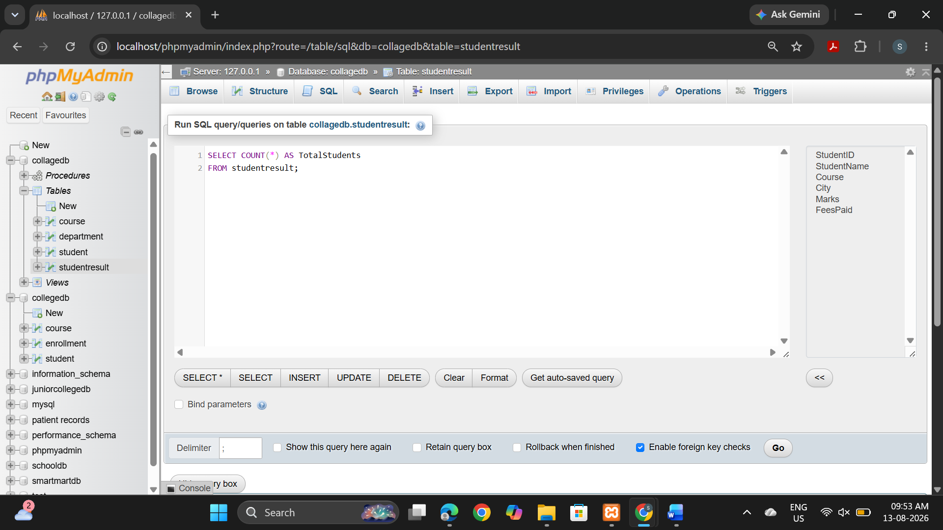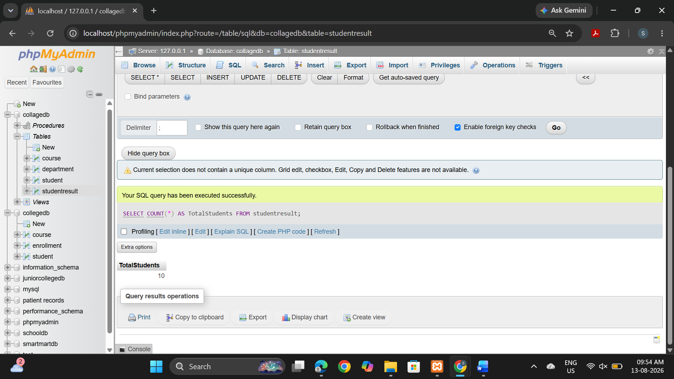

Q3) Write a MySQL query to count the number of students in each course.
The output should contain:
Column
Course
TotalStudents

SELECT Course, COUNT(*) AS TotalStudents
FROM StudentResult
GROUP BY Course;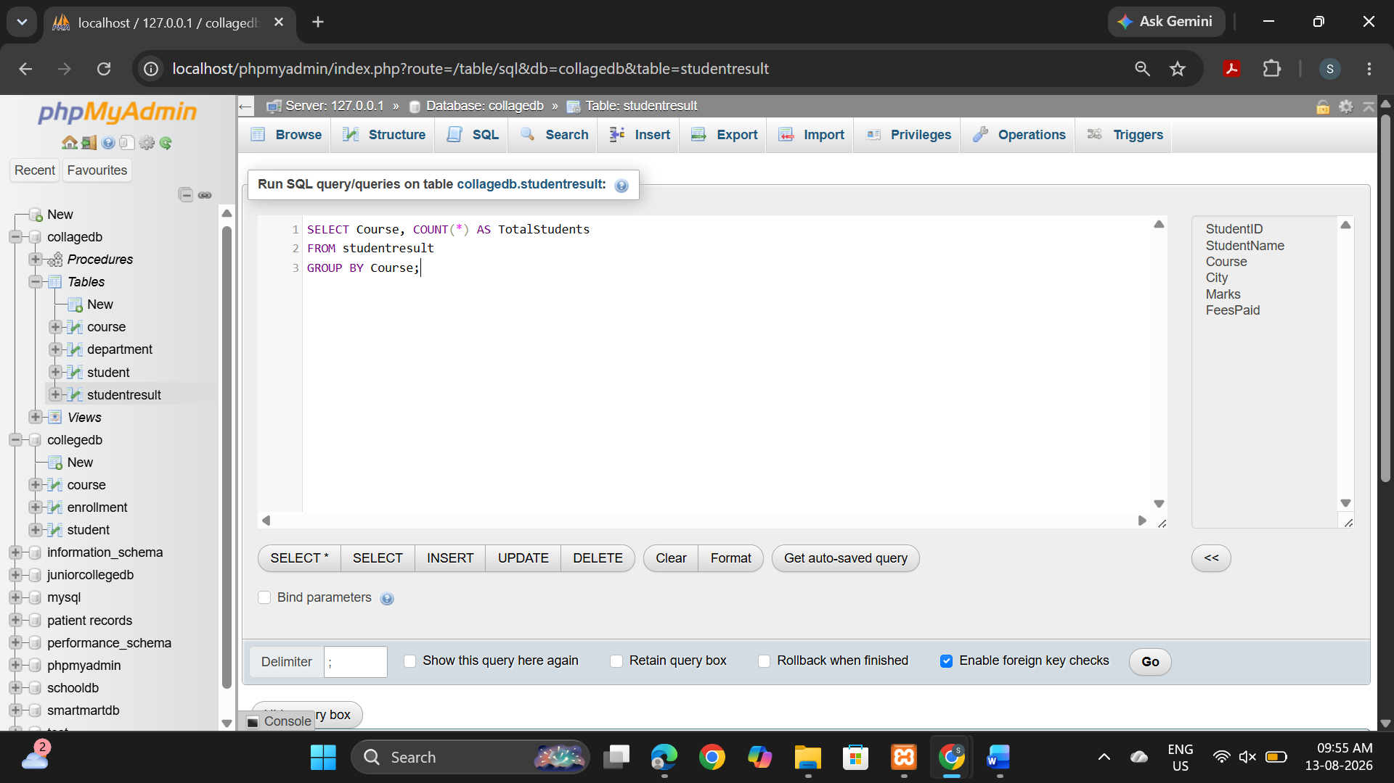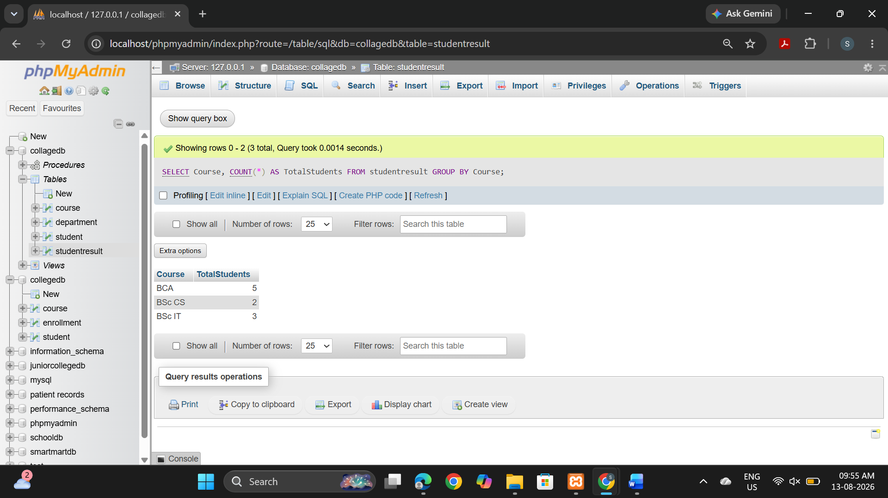

Q4) Write a MySQL query to find the average marks of students course-wise.
The output should contain:
Column
Course
AverageMarks
SELECT Course, AVG(Marks) AS AverageMarks
FROM StudentResult
GROUP BY Course;
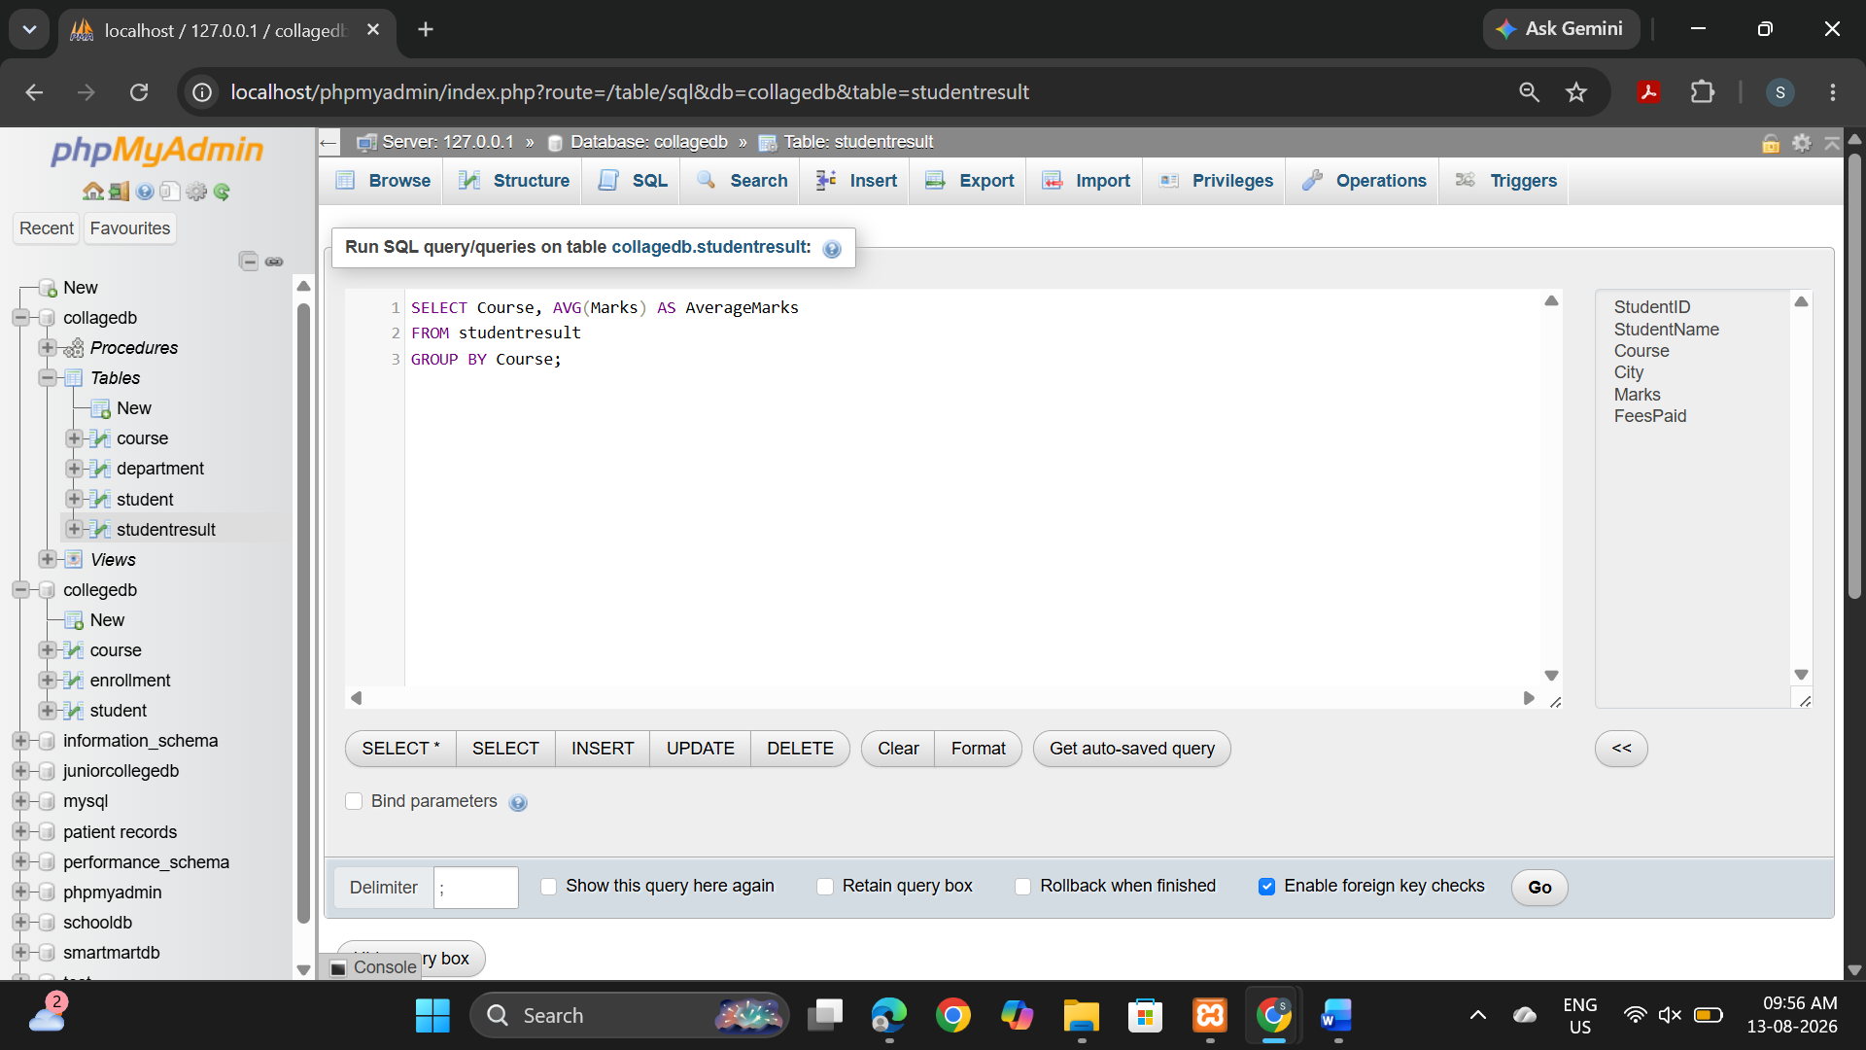
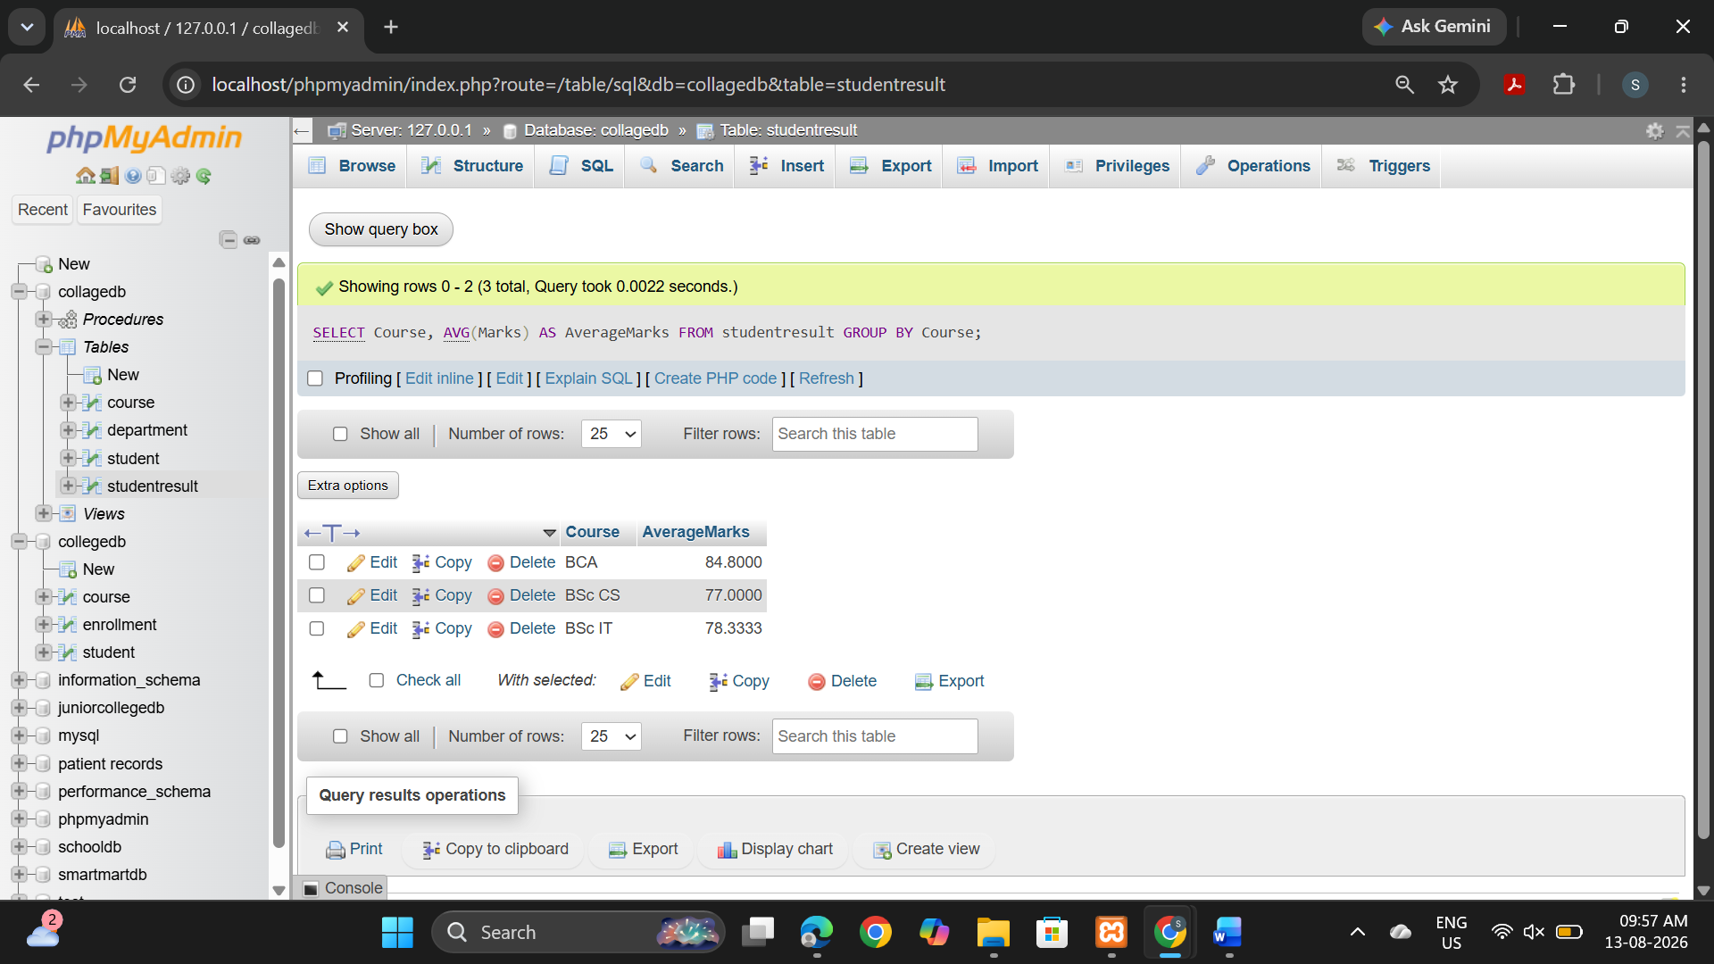

Q5) Write a MySQL query to display only those courses where the number of students is greater than 2.
Use:
Clause
GROUP BY
HAVING
SELECT Course, COUNT(*) AS TotalStudents
FROM StudentResult
GROUP BY Course
HAVING COUNT(*) > 2;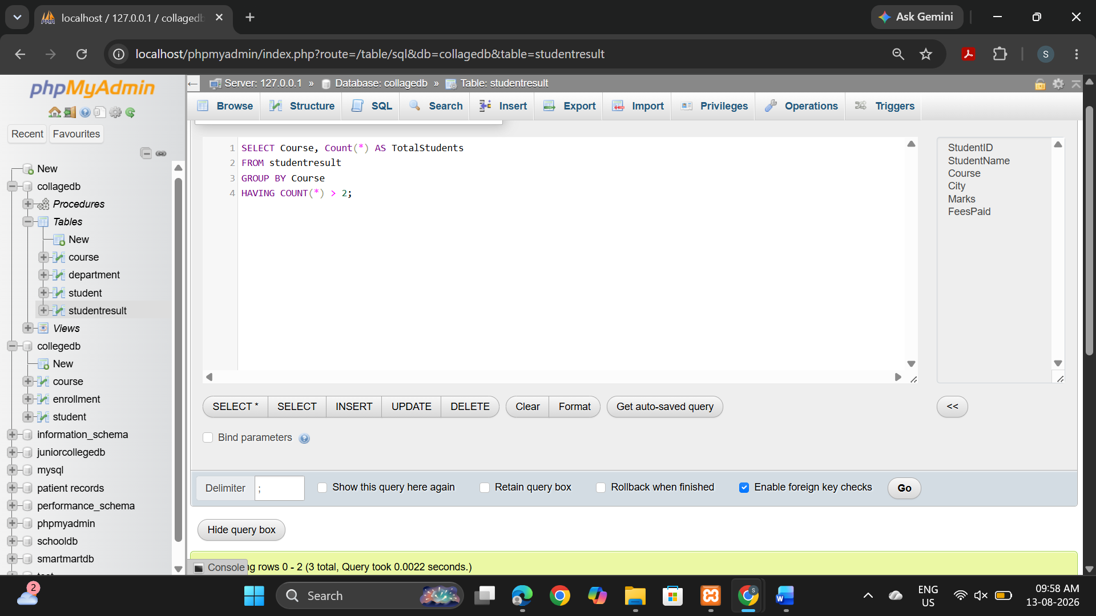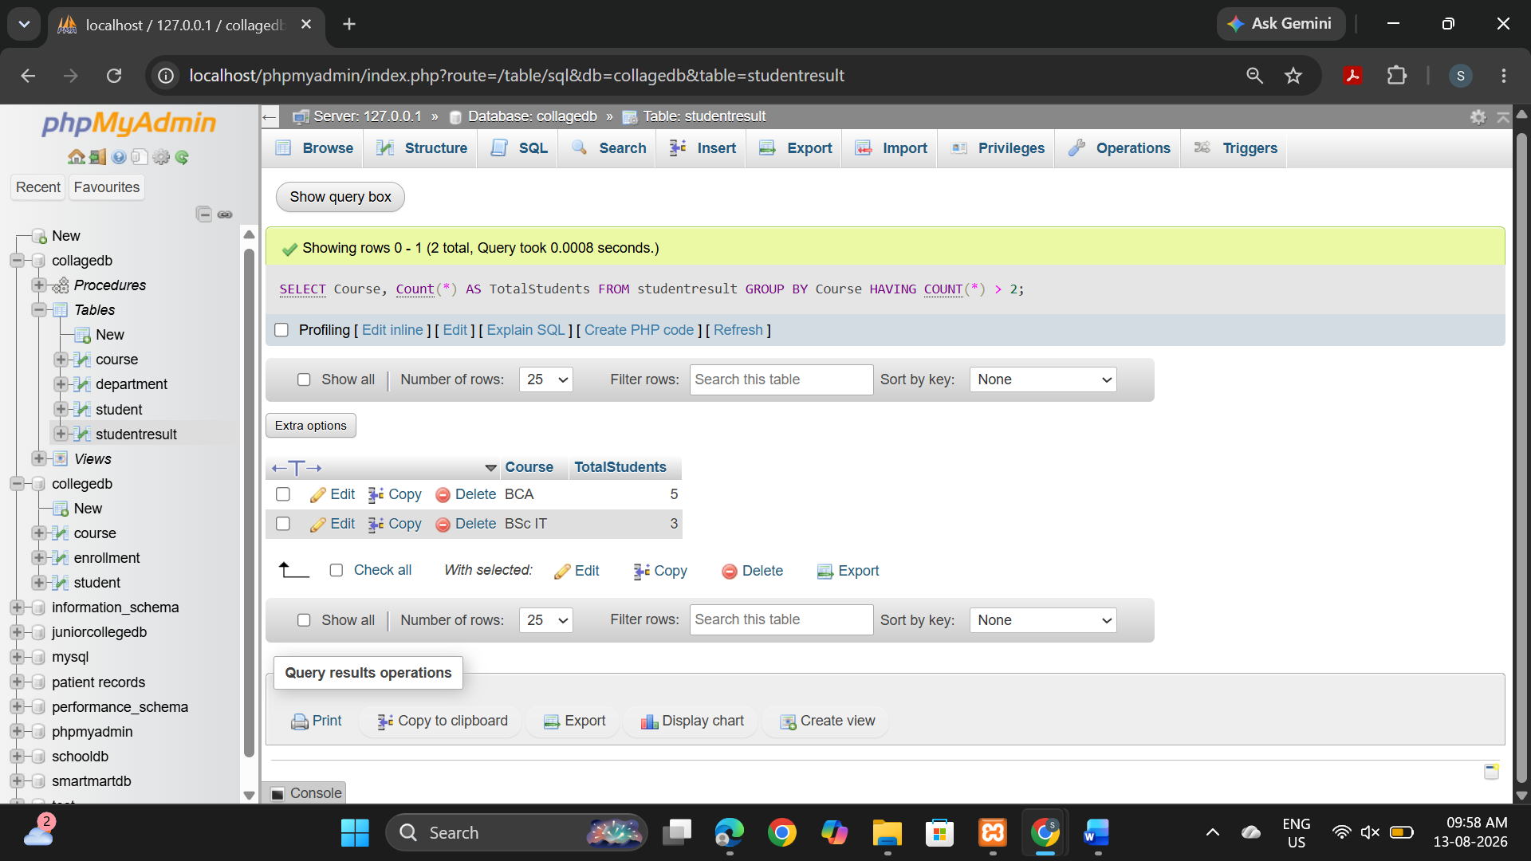

Q6) Write a MySQL query to analyze course performance.
The output should display:
Column
Course
Column
TotalStudents
AverageMarks
LowestMarks
HighestMarks

Sort the result by AverageMarks in descending order.
SELECT Course,
COUNT(*) AS TotalStudents,
AVG(Marks) AS AverageMarks,
MIN(Marks) AS LowestMarks,
MAX(Marks) AS HighestMarks
FROM StudentResult
GROUP BY Course
ORDER BY AverageMarks DESC;
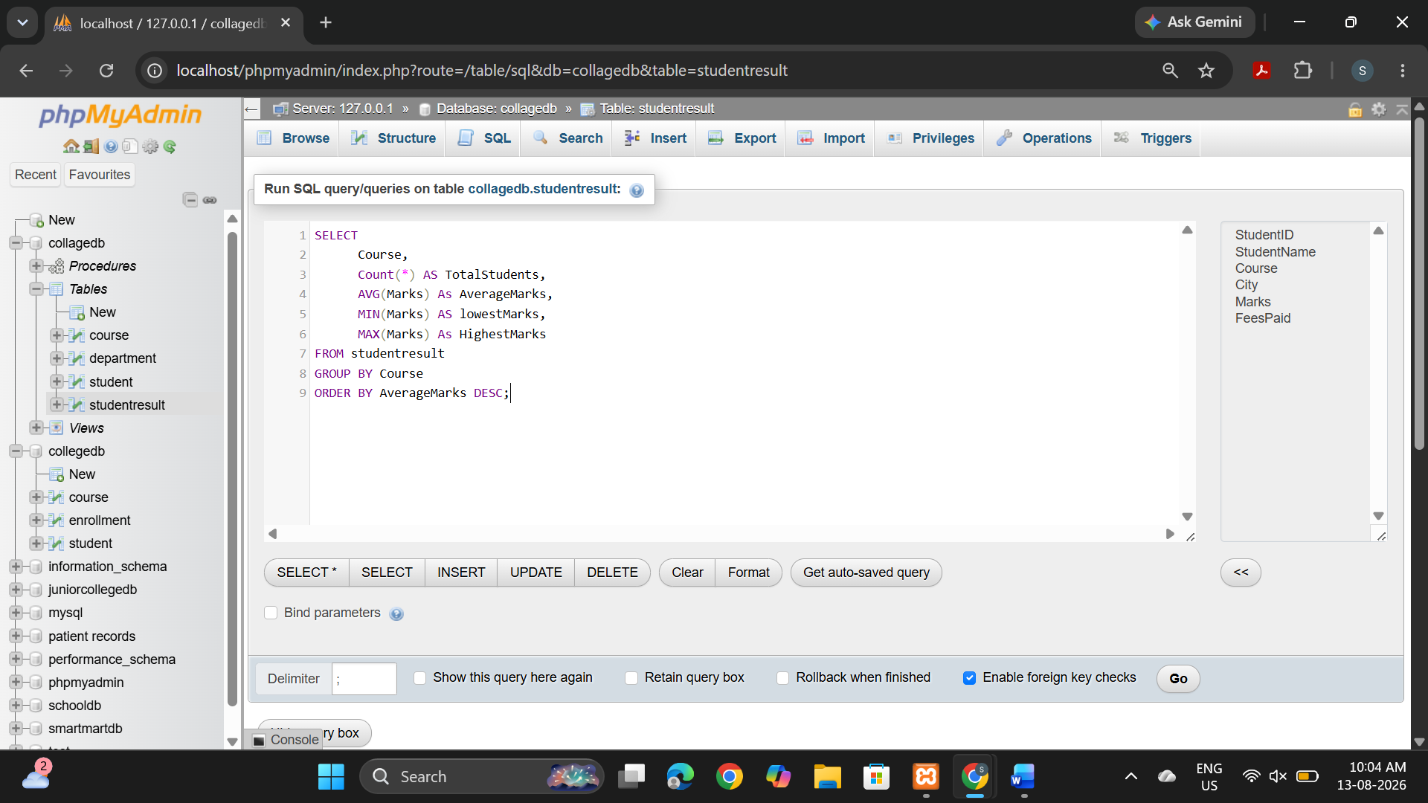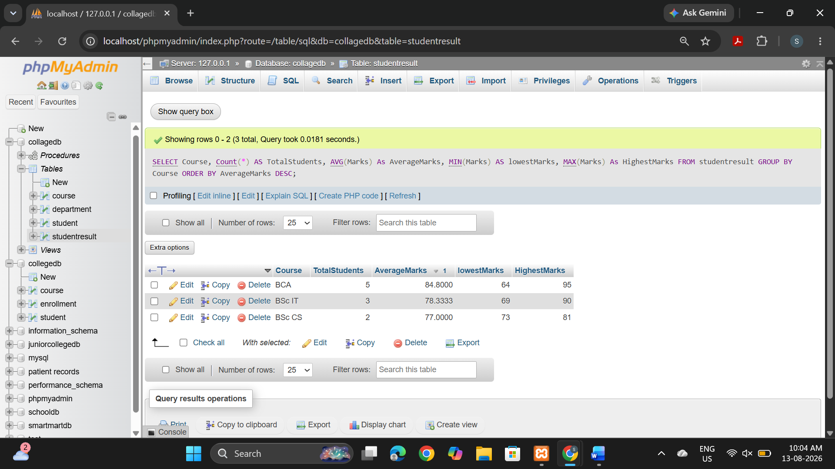

Assignment Evaluation
0: Not Done [ ]
1: Incomplete [ ]
2: Late Complete [ ]
3: Needs Improvement [ ]
4: Complete [ ]
5: Well Done [ ]
Signature of Instructor: _______________

